## **Simulation and Testing**

**Simulation Strategy:** The primary objective of the simulation is to evaluate the effectiveness of the hazard zone mapping model for construction equipment within highway work zones. The simulation will be conducted using Webots, a robot simulation software, to replicate real-world scenarios. The strategy involves simulating equipment movements, detecting worker presence within the hazard zone, and evaluating the response and outcomes based on predefined criteria.

**Environment Setup:** A realistic highway work zone environment will be created in Webots, including static objects like barriers and road signs to replicate real-world conditions. Construction equipment and worker objects will be placed within this environment to simulate actual work zone scenarios.

**Random Speed and Worker Location Generation:** To simulate variability in equipment speeds, 50 random speeds will be generated within the range of 5 to 50 km/hr. Additionally, a grid of points representing potential worker locations will be established ahead of the equipment, with intervals of 1 meter, ensuring that the equipment attains the target speed before reaching these points. This grid will span 10 meters across the road and extend 5 meters along the road (Figure 1).

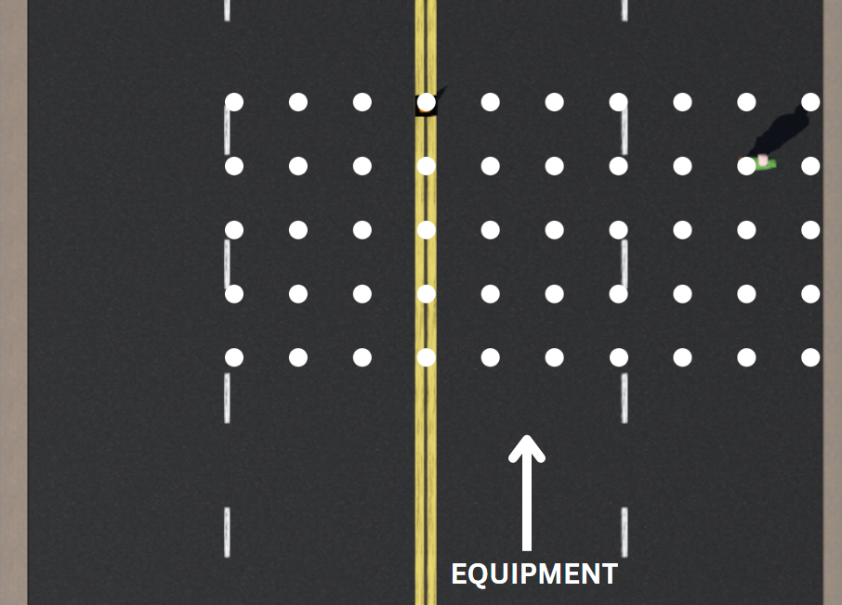

Figure 1. Grid points for worker locations

**Simulation Scenarios:** Two distinct scenarios will be simulated to comprehensively evaluate the hazard zone model.

Scenario 1: Equipment Moving Forward

In the first scenario, the equipment will move forward at one of the randomly generated speeds. When a worker enters the hazard zone, the equipment will continue at the same speed for 2.5 seconds, simulating the operator's reaction time. Following this, the equipment will decelerate at a rate of 1.9 m/s² until it stops. The distance between the equipment and the worker when the equipment stops will be measured. The outcomes of the simulation will be classified as follows:

* **False Negative:** The equipment hits the worker or comes within 1 meter before stopping.
* **True Positive:** The equipment stops with the worker 1 to 2 meters away.
* **False Positive:** The equipment stops with the worker more than 2 meters away.
* **True Negative:** No worker enters the hazard zone and no worker is within 2 meters.

Scenario 2: Equipment Turning

The second scenario will involve the equipment executing a turning maneuver at one of the randomly generated speeds. The same steps for detection, reaction, deceleration, distance measurement, and outcome classification will be followed as in the first scenario. This scenario will test the model's effectiveness under more complex movement conditions.

**Data Collection and Analysis:** Data will be collected for each simulation run, including the speed of the equipment, worker location, distance to the worker when the equipment stops, and the result classification. This data will be analyzed to evaluate the effectiveness of the hazard zone model under various conditions.

# **Results**

## **Theoretical Derivation of Hazard Zone**

The hazard zone mapping model proposed in this study is based on a probabilistic approach using a bivariate Gaussian distribution. The derivation of the hazard zone involves the following parameters:

1. **Center Point (𝜇𝑥, 𝜇𝑦​):** The center point of the hazard zone corresponds to the position of the construction equipment within the highway work zone.
2. **Standard Deviations (𝜎𝑥, 𝜎𝑦):** The standard deviations along the x and y axes determine the spread or width of the hazard zone in the respective directions. These standard deviations are functions of the equipment's speed and direction.

Expressions for 𝜎𝑥 and 𝜎𝑦 in terms of speed are initially determined based on theoretical hazard zone dimensions recommended in existing research, and then refined through a software simulation. A six-step procedure is recommended in a work by Shen et al., (2016) to draw hazard zones around various construction equipment. These procedures are used to come up with initial values for the coefficients. The procedure is detailed below:

1. **Equipment Footprint:** This parameter is the overall dimension of the equipment, which depends on the type of equipment. The equipment is assumed to have a length of 5 meters and a width of 2.5 meters for this analysis.
2. **Initial Safety Boundary:** The initial safety boundary is taken to be 2 meters around the equipment.
3. **Equipment Function:** This step involves determining the required safety distance based on the function and type of movement involved in the equipment. For example, the hazard zone of an excavator will have a circular shape with a radius governed by the size of the rotating arm. As the main focus of this study is on moving equipment such as wheel loaders and dump trucks, the hazard zone is governed by the speed of the equipment. This forms the basis for computing the distance required for the equipment to stop once a hazard is perceived by the operator, which is addressed in steps 4 and 5. Although this step considers the turning radius as an additional criterion in the original research, it is not considered in this study as the proposed hazard zone gets data in real-time and follows the equipment path dynamically.
4. **Operator Reaction Distance (RD):** The reaction distance is the distance covered by the equipment between the moment the operator perceives the hazard and takes measure. It is computed as:

where 𝑣 is the speed of the equipment in m/s, and 𝑡 is the reaction time. The reaction time 𝑡 is recommended to be 2.5 seconds (MUTCD, 2009; Shen et al., 2016; J. Wang & Razavi, 2016). Thus, the equation simplifies to:

1. **Braking Distance (BD):** The braking distance is the distance the equipment will travel between the moment the operator takes action and the equipment comes to a full stop. This distance is computed as (Shen et al., 2016; J. Wang & Razavi, 2016):

where 𝑣 is the speed of the equipment in m/s, and 𝑎 is the deceleration of the equipment in m/s², taken as 1.9 m/s² (J. Wang & Razavi, 2016) [0.7 another research, and around 1.4 from the simulation (this is taken)]. The braking distance could thus be expressed in terms of speed as:

1. **Determine Hazard Zone:** The final step involves determining the resulting hazard zone based on steps 1 through 5. In this study, the hazard zone is taken to be elliptical in shape, following the projection of a bivariate Gaussian distribution with the major axis representing the direction of movement of the equipment. The lengths of the major and minor axes of the ellipse are computed based on the values in the previous steps as follows:

* Major axis:
* Minor axis:

To determine 𝜎𝑥 and 𝜎y, these values are equated with the equation of the ellipse projection of the proposed bivariate Gaussian probabilistic plot. The hazard zone is assumed to represent the ellipse with a 70% probability of hazard.

For a bivariate Gaussian distribution, the equation of the ellipse representing the 70% probability contour is given by:



where k is a constant that corresponds to the 70% probability contour. For a 70% confidence level, the value of k is obtained from the chi-squared distribution table corresponding to the 30th percentile (i.e. the 70% hazard probability) for 2 degrees of freedom. This value is approximately 0.713.

The major and minor axes of the ellipse in terms of the standard deviations are:

* Major axis:
* Minor axis:

Equating these with the calculated dimensions:

* Major axis:
* Minor axis:

By this derivation, it is obtained that the standard deviation along the major axis is , indicating that the major axis of the hazard zone dynamically adjusts based on the speed of the equipment. These coefficients are used as initial values in the simulation and are updated based on the simulation results to ensure accuracy. On the other hand, the standard deviation along the minor axis is found to be 3.846, indicating that the minor axis of the hazard zone remains constant regardless of the equipment's speed.